**Assignment 1**

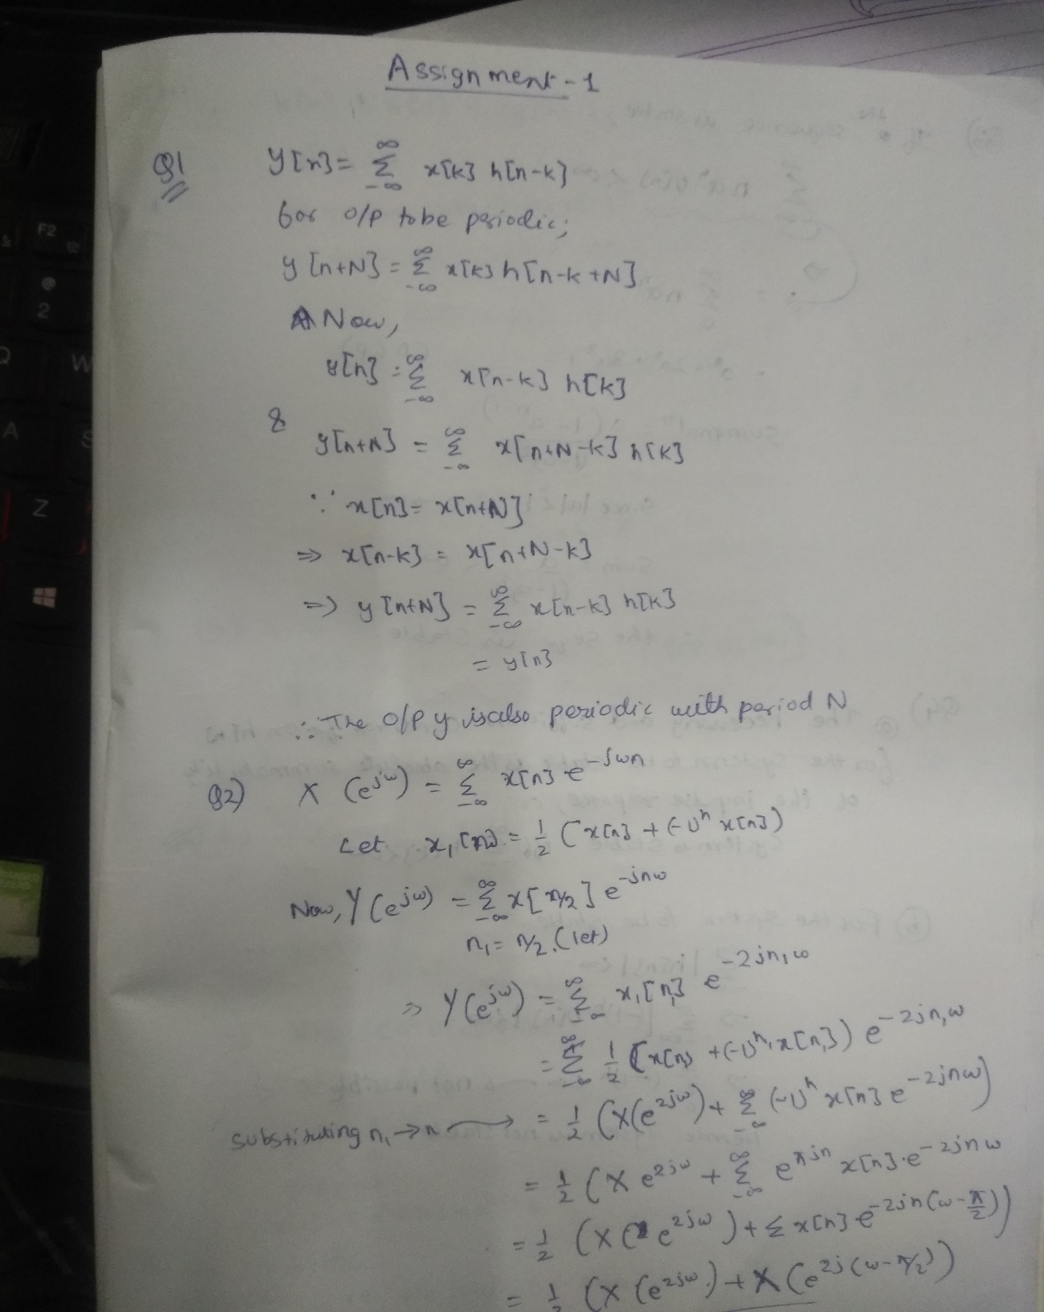

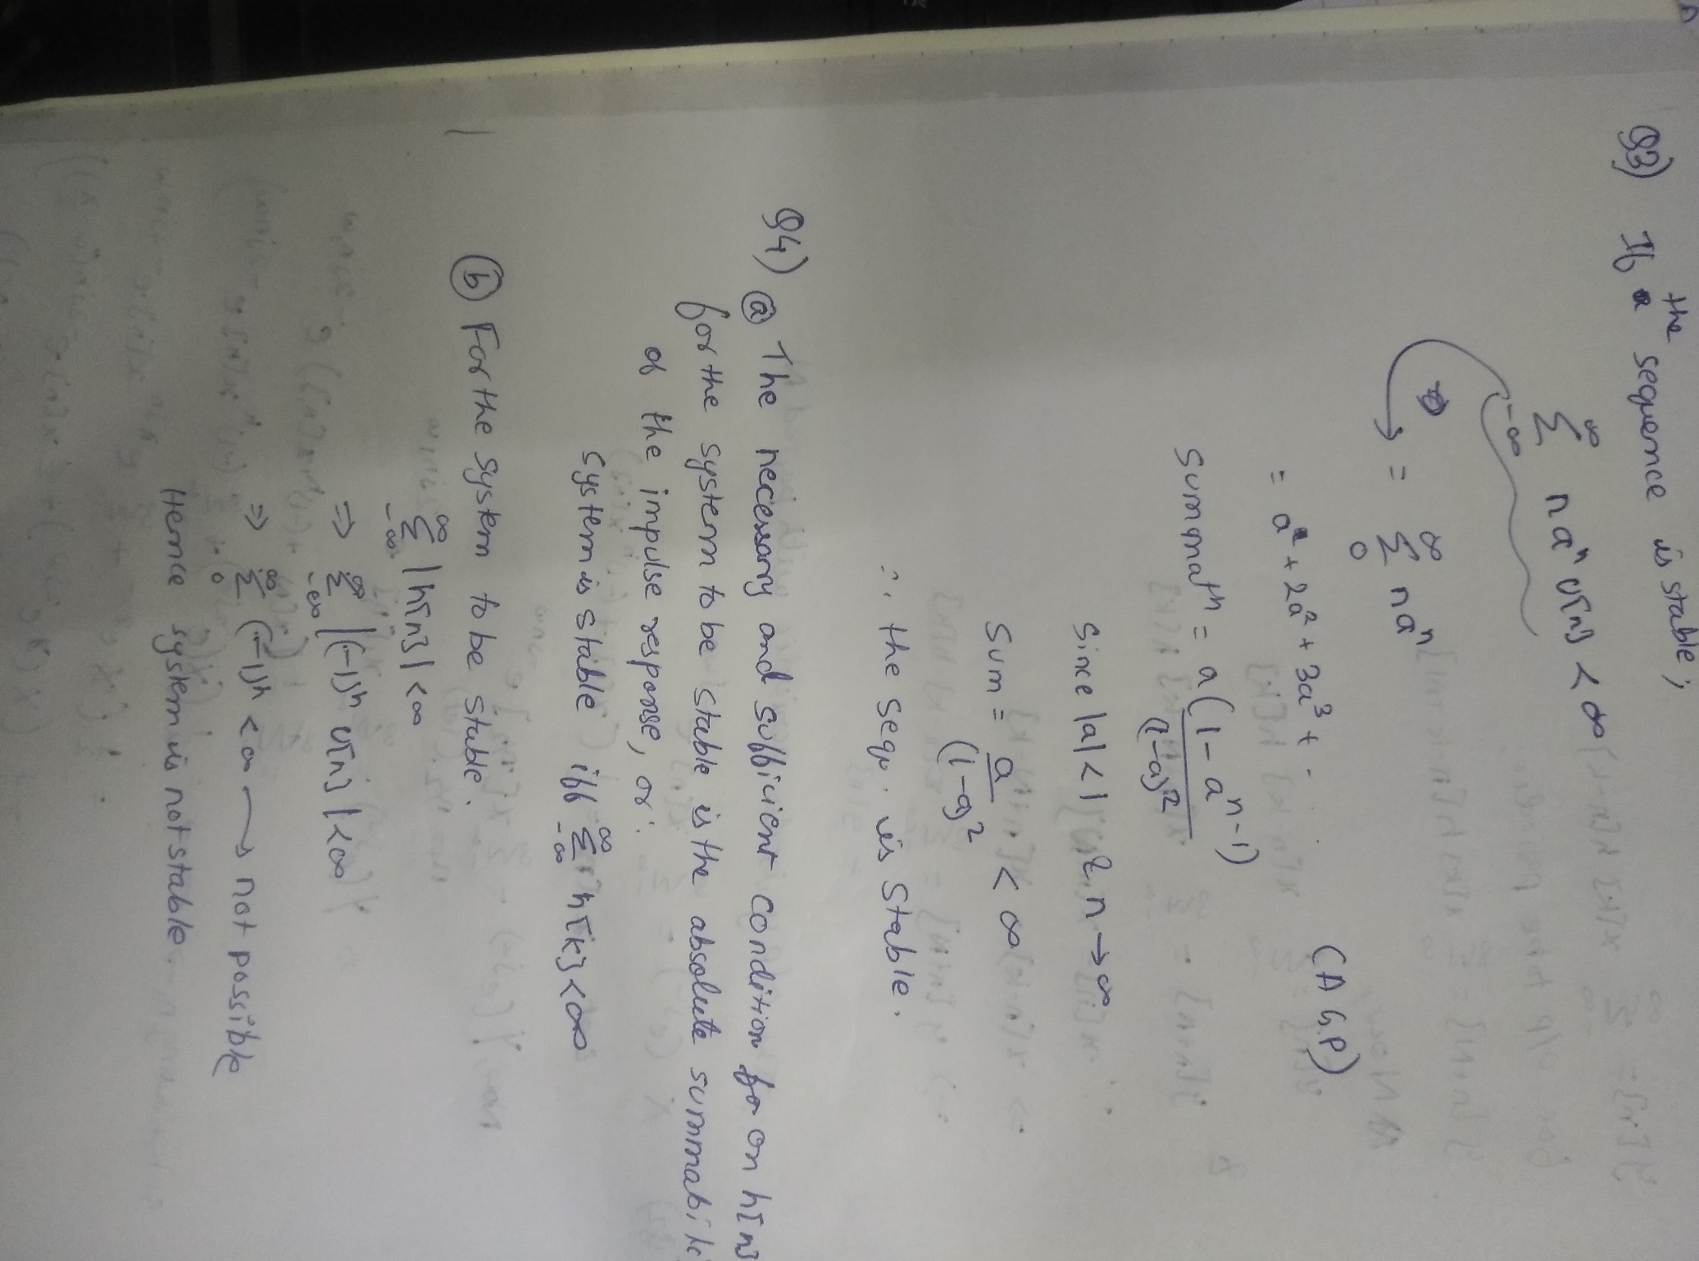

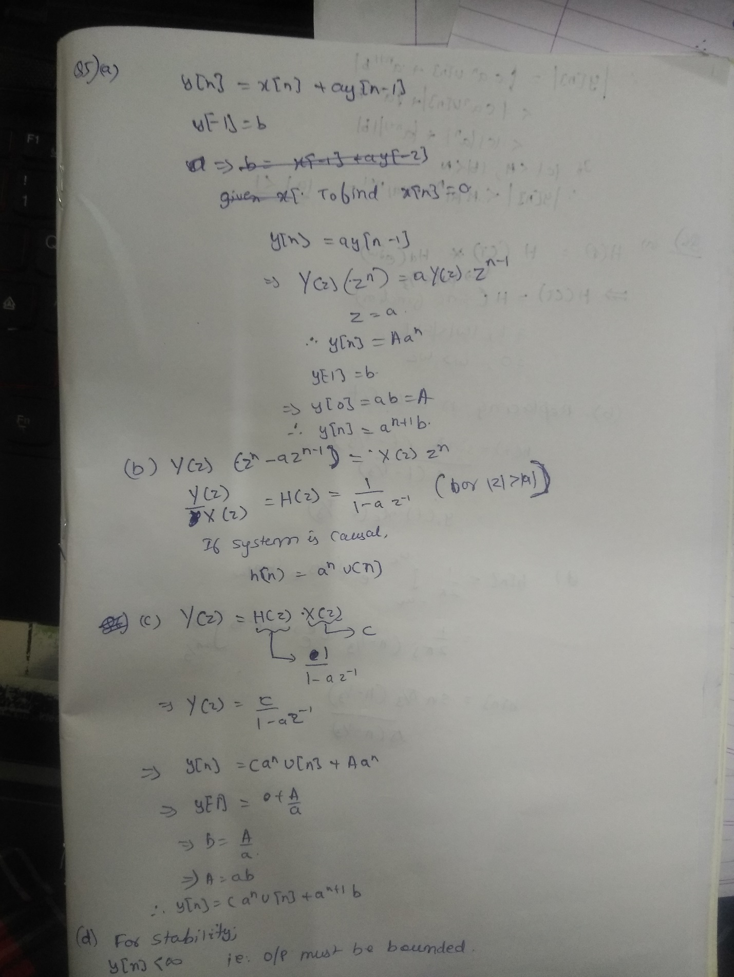

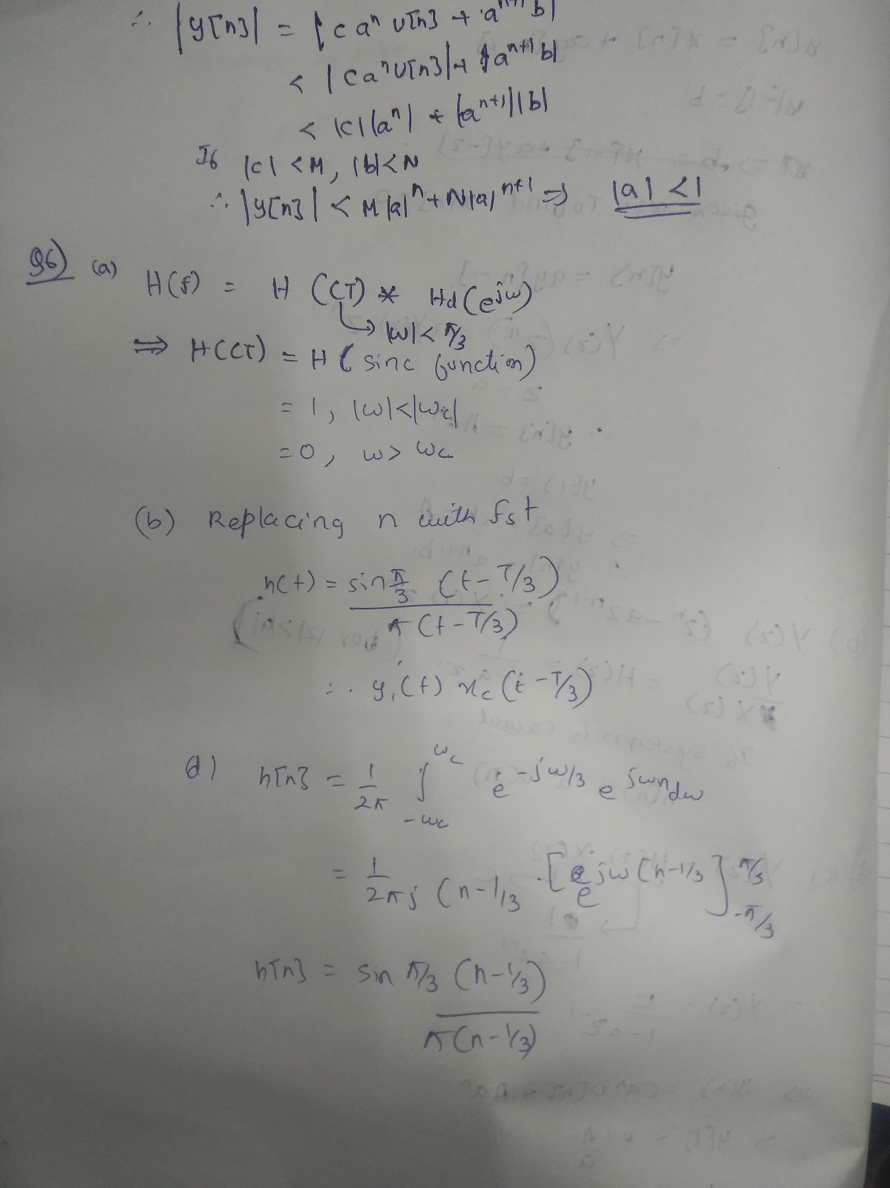

Question 7:

1. The low pass filter formed:  
   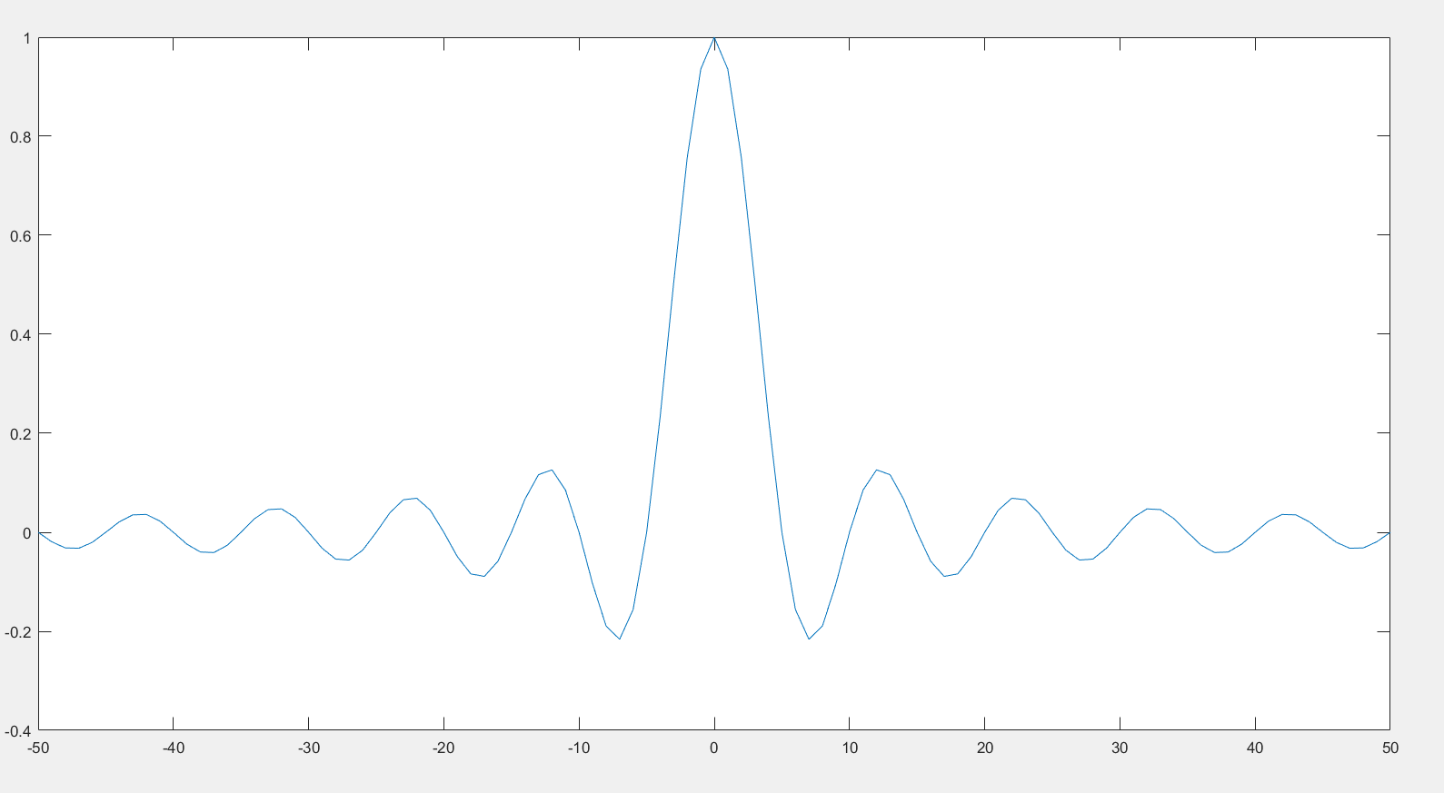
2. Gain of the filter= 14.6 (found by freqz(myfilter))

d)Code used:

n=-50:50;  
myfilter=sinc(0.2*n);  
myfilter1=((-1).^n).*myfilter;  
plot(n,myfilter1);

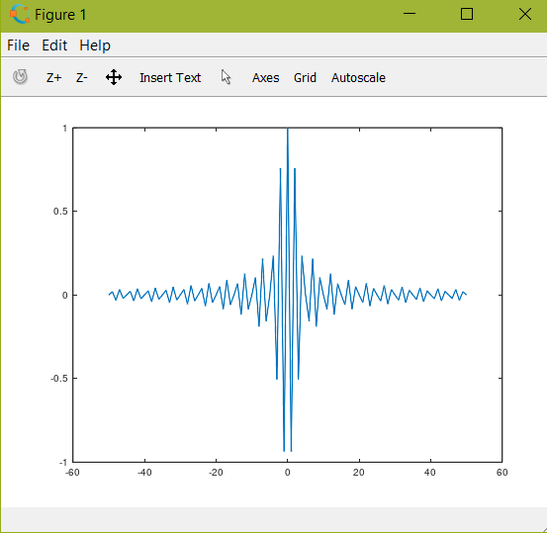

Frequency response:

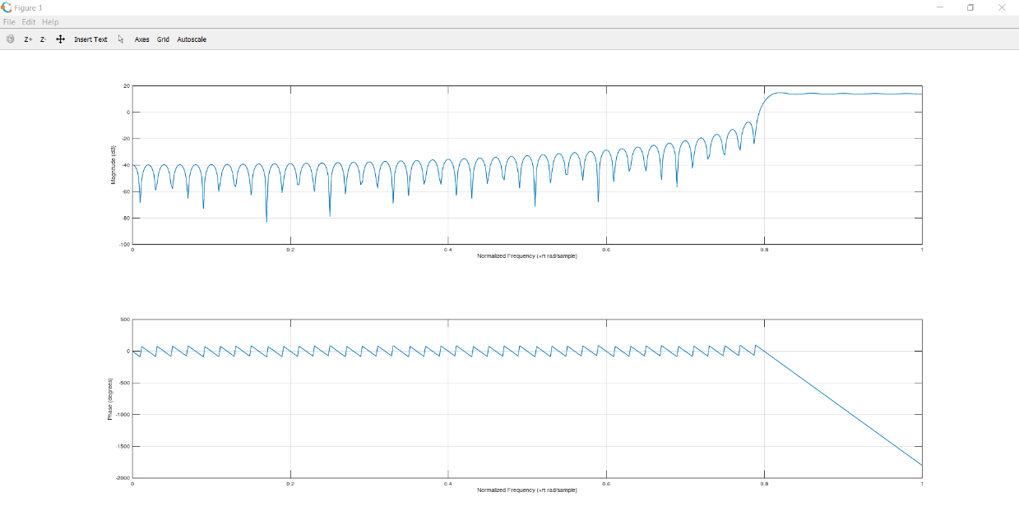

It is a high pass filter.

e) Filter formed:  
Code used:

n=-50:50;

myfilter=sinc(0.2*n);

myfilter2=cos(0.5*pi*n).*myfilter;

plot(n,myfilter2);

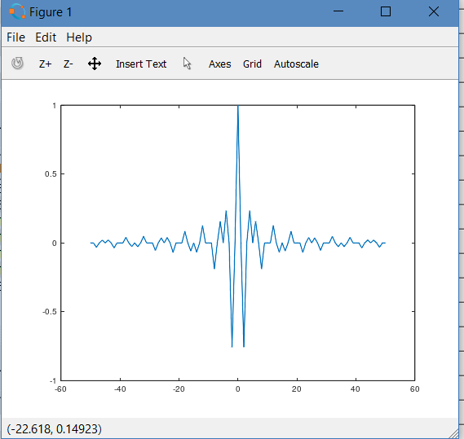

Frequency response:

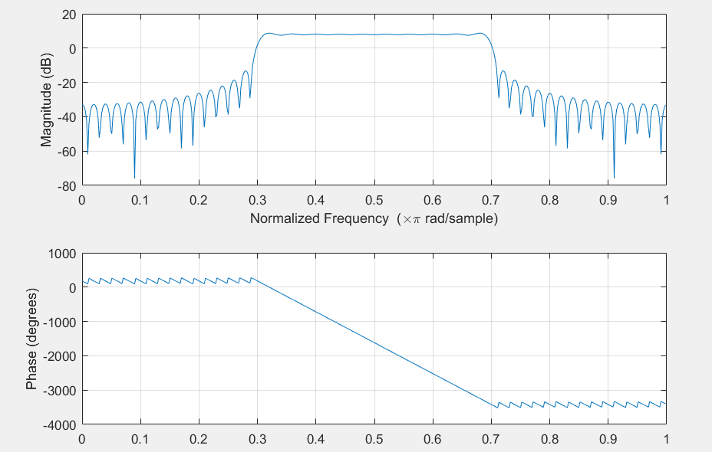

It is a bandpass filter.

f) Filter formed:  
code used:  
n=-50:50;

myfilter=sinc(0.2*n);

myfilter2=(sinc(0.1*n)*0.1).*myfilter;

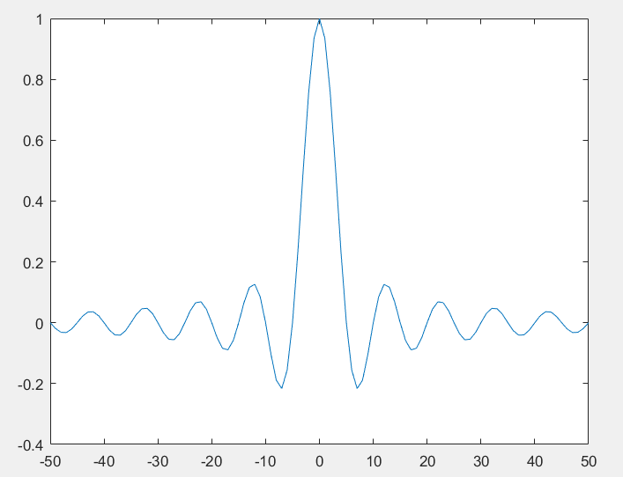

Frequency response:

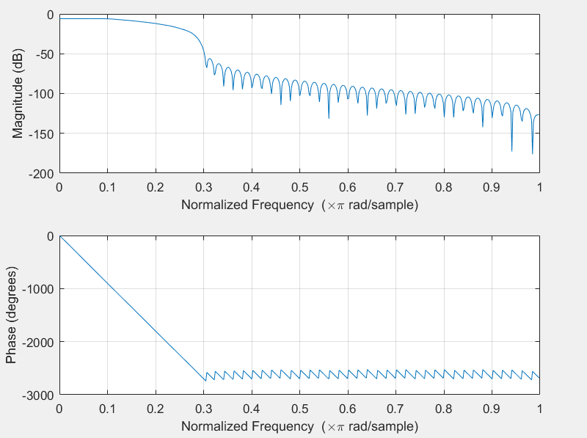

It is a low pass filter.

g) the sinc function gives a high response in only a specified region (low frequency).

When a cos function is convolved with a sinc function, higher frequencies are nullified and hence we get a band pass filter